

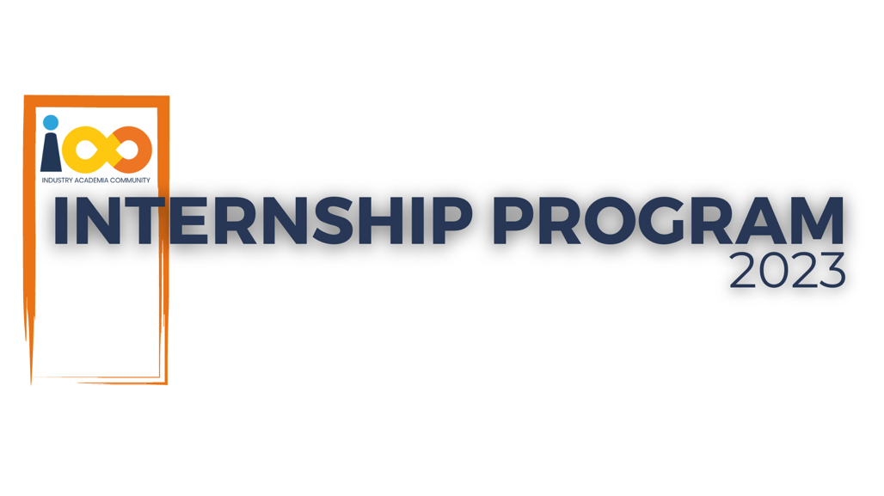
PROJECT REPORT
Data Analytics
Student Insights : A Power BI Approach

Created By: | Vedant Rakshe | Approved By: | Suraj Mane
Created On: | 15-03-2026 | Approved On: | 15-03-2026

Page left blank intentionally

INDEX
1 PROJECT DETAILS 2
2 SUMMARY 2
3 INTRODUCTION 2
3.1 Background 2
3.2 Stakeholders 2
3.3 Objectives 2
4 METHODOLOGY 2
4.1 Considerations & Assumption 3
4.2 Approach 3
4.3 Activities 3
5 TARGETTED V/S ACHIEVED OUTPUT 3
6 CONCLUSION 3
7 APPENDICES 4
7.1 Appendix A – Title 4

PROJECT DETAILS

Project Name | Student Insights : A Power BI Approach
Project Sponsor | Harshada Topale
Project Manager | Harshada Topale
Start Date | 24/07/2024 | Completion Date | 15/03/2026

SUMMARY
This project was needed to gain a deeper understanding of the factors influencing student outcomes, such as academic performance and expected salary. By analysing this data, educational institutions, policymakers, and stakeholders can make informed decisions to improve student support services, curriculum design, and career counselling. Understanding these factors can also help in identifying areas where students may need additional resources or support to achieve better outcomes.

INTRODUCTION

Background

This project aims to analyse a comprehensive dataset of students, providing insights into various factors affecting their academic performance and career expectations. The dataset includes attributes such as GPA, family income, experience with Python programming, expected salary, and more. Millions of students apply for internship/job every year, resumes play an important role in playing first impression. The recruiters spend max of 2-3 minutes reviewing a resume after it landed in their mailbox or job board, ATS application. Surprising more than 70% of resumes get rejected in the initial stage.

Stakeholders

The primary problem this project aims to address is the lack of comprehensive insights into the factors affecting student performance and career outcomes. Educational institutions often struggle to identify the key determinants of academic success and career readiness among their students. This project seeks to bridge this gap by analyzing a detailed dataset of student attributes and providing actionable insights.

Objectives

The objective of this project is to utilize Power BI to analyze and visualize a dataset of student information, including demographics, academic performance, graduation details, family income, and programming experience. The project aims to uncover insights such as the distribution of students across various categories, the relationship between family income and GPA, and variations in expected salaries. Additionally, it will identify outliers in course completion and evaluate student participation in events, ultimately providing a comprehensive understanding of the factors influencing student success.

METHODOLOGY
These conventions are all about the positions of line breaks, how many characters should go on a line, and everything in between.

Considerations & Assumption

The project faced several constraints, including data availability limited to the provided dataset, which may not cover all potential factors influencing student outcomes. There were challenges related to data quality, such as incomplete or inconsistent data points, and technical limitations of Power BI in handling large datasets efficiently. Additionally, the project was bound by a strict timeframe and resource constraints, limiting the extent of analysis and refinement. These constraints required careful planning and prioritization to ensure the project objectives were met within the given limitations.

Challenges encountered during the project included data cleaning and preparation, such as handling missing values and standardizing data formats. Statistical analysis posed difficulties in identifying and managing outliers and selecting appropriate methods to analyze relationships between variables. Visualization challenges involved creating clear, intuitive, and interactive visual representations of the data to provide meaningful insights to stakeholders. Interpreting complex data findings and ensuring effective communication with stakeholders to incorporate their feedback were also significant challenges.

Assumptions were made to facilitate the analysis, including assuming the dataset's accuracy and completeness, representativeness of the broader student population, and consistency of variables. Technical feasibility assumptions were made about Power BI's capabilities and the project team's expertise in using it. Stakeholder engagement assumptions were necessary to ensure timely feedback and guide the analysis process. These assumptions helped streamline the project timeline, focus resources on critical aspects, and generalize findings to provide broader recommendations. Despite the challenges and constraints, these assumptions enabled the project team to deliver valuable insights effectively.

Approach

To solve the problem, we adopted a structured, data-driven approach. The process began with a comprehensive requirement-gathering phase to understand stakeholder needs and the scope of the analysis. We then cleaned and pre-processed the dataset to ensure accuracy and consistency. This was followed by exploratory data analysis (EDA) to identify key patterns and relationships within the data. Based on these insights, we developed a series of visualizations to effectively communicate findings. Finally, an interactive Power BI dashboard was created to enable stakeholders to explore the data dynamically. This structured approach ensured that the analysis was thorough, accurate, and aligned with stakeholder expectations.

Activities

The project involved several key activities, starting with requirement gathering to understand the objectives and expectations of stakeholders. This was followed by data cleaning and preparation to ensure the dataset was accurate and consistent. We then conducted exploratory data analysis (EDA) to uncover key insights and patterns. Visualization development was the next step, creating intuitive charts and graphs to present the findings. Finally, we developed an interactive Power BI dashboard to allow stakeholders to explore the data and insights dynamically. Each activity was crucial in ensuring the project's success and delivering valuable insights to the stakeholders.

TARGETTED V/S ACHIEVED OUTPUT

The targeted output of the project, as outlined in the project plan, included a comprehensive dataset analysis, insightful visualizations, and an interactive Power BI dashboard. We successfully achieved these goals by providing a detailed analysis of student attributes, creating visualizations to display the distribution of students and the relationship between various factors, and developing a dynamic dashboard for stakeholder use. While there were minor deviations, such as handling unforeseen data quality issues and adjusting visualization formats based on stakeholder feedback, these adjustments ultimately enhanced the project's overall quality and relevance.

CONCLUSION
The project has proven to be highly useful for stakeholders by providing deep insights into factors influencing student outcomes, such as GPA, family income, and programming experience. The interactive Power BI dashboard allows for ongoing exploration and analysis, aiding in informed decision-making and strategic planning. Future scope includes expanding the dataset to include more variables and longitudinal data, enhancing the dashboard with predictive analytics features, and integrating additional data sources to provide a more comprehensive analysis. This project sets a strong foundation for continuous improvement in understanding and supporting student success.

APPENDICES

Appendix A – Data Dictionary

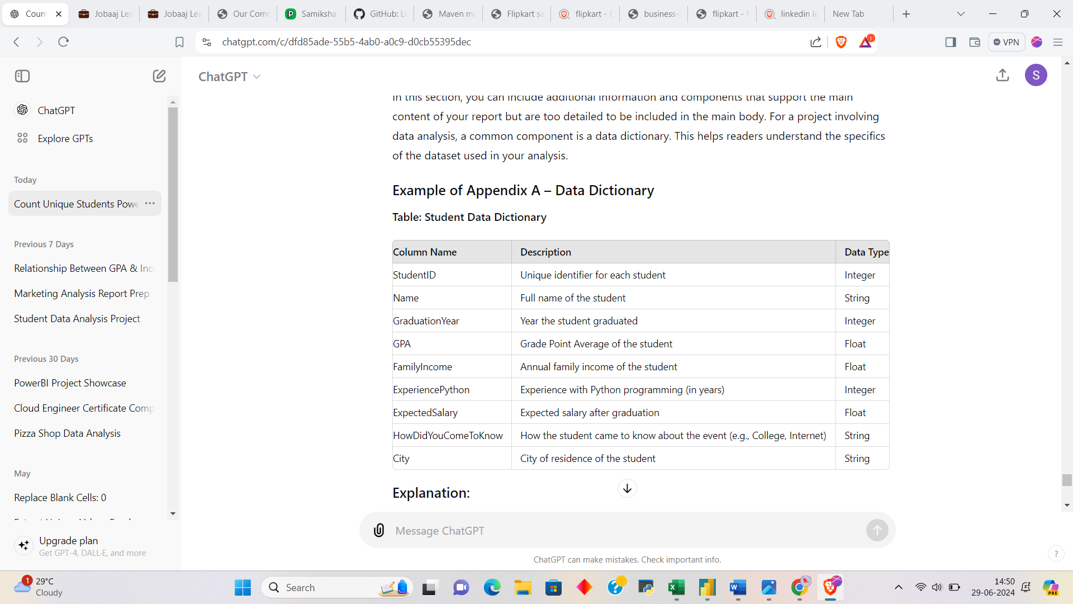
This report summarizes the comprehensive Data Analysis and Visualization project conducted for the Cloud Counselage student dataset. The project transformed raw student data into a professional 3-page interactive Power BI Dashboard to identify talent trends, academic performance, and marketing effectiveness.

- Part 1: Dashboard Overview
- Page 1: Executive Talent Summary
This page serves as the high-level "Command Center." It focuses on the overall scale of the project and the technical proficiency of the student pool. It is designed for stakeholders to quickly understand the size and the background of the audience reached.
- Key Focus: Total reach, technical skills (Python), and recruitment timelines.
- User Impact: Provides immediate answers to "how many students" and "when do they graduate."
- Page 2: Institutional & Regional Deep-Dive
This page transitions from "how many" to "where from." It analyzes the performance of specific colleges and cities to identify academic hubs.
- Key Focus: College rankings, geographic density, and event engagement by major.
- User Impact: Helps the organization identify which colleges and cities are producing the highest-performing students.
- Page 3: Strategic Career & Socioeconomic Insights
The final page explores the "Why" behind the data. It correlates socioeconomic factors (Family Income and Leadership) with career goals (Expected Salary).
- Key Focus: Global reach (Map), financial expectations, and leadership influence.
- User Impact: Provides deep insights into student motivations and helps recruiters identify "High-Value Talent" through a detailed matrix.

- Part 2: Detailed Question & Answer Analysis
Based on the original 18-question requirement, here are the insights derived from the dashboard:
- Basic Questions (Q1 - Q8)
# | Original Question | Dashboard Answer / Insight
1 | How many unique students are there? | 2,157 unique students participated.
2 | What is the average GPA of the students? | The average GPA across the entire pool is 8.04.
3 | What is the distribution of students across graduation years? | Highest concentration is in 2023 & 2024, with a tapering off in 2025/26.
4 | Distribution of students' experience with Python? | Most students have 4 to 8 months of Python experience.
5 | What is the average family income of the students? | 86% of the students come from the 0-2 Lakh income bracket.
6 | How does GPA vary among different colleges? (Top 5) | Vidyalankar Institute and B.K. Birla are among the top-performing institutions.
7 | Are there any outliers in the quantity of courses completed? | Yes, a few students completed significantly more courses (over 100).
8 | What is the average GPA for students from each city? | Cities like Wardha (8.34) and Una (8.30) show higher than average GPAs.
- Strategic Relationship Questions (Q9 - Q13)
# | Original Question | Dashboard Answer / Insight
9 | Relationship between family income and GPA? | GPA remains relatively stable (~8.0) across all income brackets.
10 | How many students from various cities? (Map) | Distribution is global, with the heaviest concentration in India and regional clusters in Africa and Europe.
11 | How does expected salary vary with GPA, Income, and Exp? | Students with higher Python experience tend to have higher salary expectations.
12 | Which events attract students from specific fields? | Internship Programs attract the most diverse group across all designations.
13 | Relationship between leadership and GPA/Salary? | Leadership roles show a slight positive correlation with both higher GPA and higher Salary goals.
- Moderate & Operational Questions (Q14 - Q18)
# | Original Question | Dashboard Answer / Insight
14 | How many students graduate by the end of 2024? | Derived by filtering the count for the 2023 and 2024 cohorts.
15 | Which promotion channel brought in the most students? | WhatsApp is the clear winner, followed by Email and SPOCs.
16 | How many students are interested in Data Science? | Found by filtering the Data Science event keywords in the total pool.
17 | High GPA & Experience vs. High Salary? | Captured in the Matrix Grid, allowing for direct sorting of top talent.
18 | Top 5 colleges that heard via "College" channel? | Wilson College leads the list of colleges with strong internal promotion.

- Conclusion
This dashboard provides a 360-degree view of the student ecosystem. It identifies not just who the students are, but where they come from, what they expect from their careers, and which marketing strategies effectively brought them to Cloud Counselage.
PROJECT IMAGES:
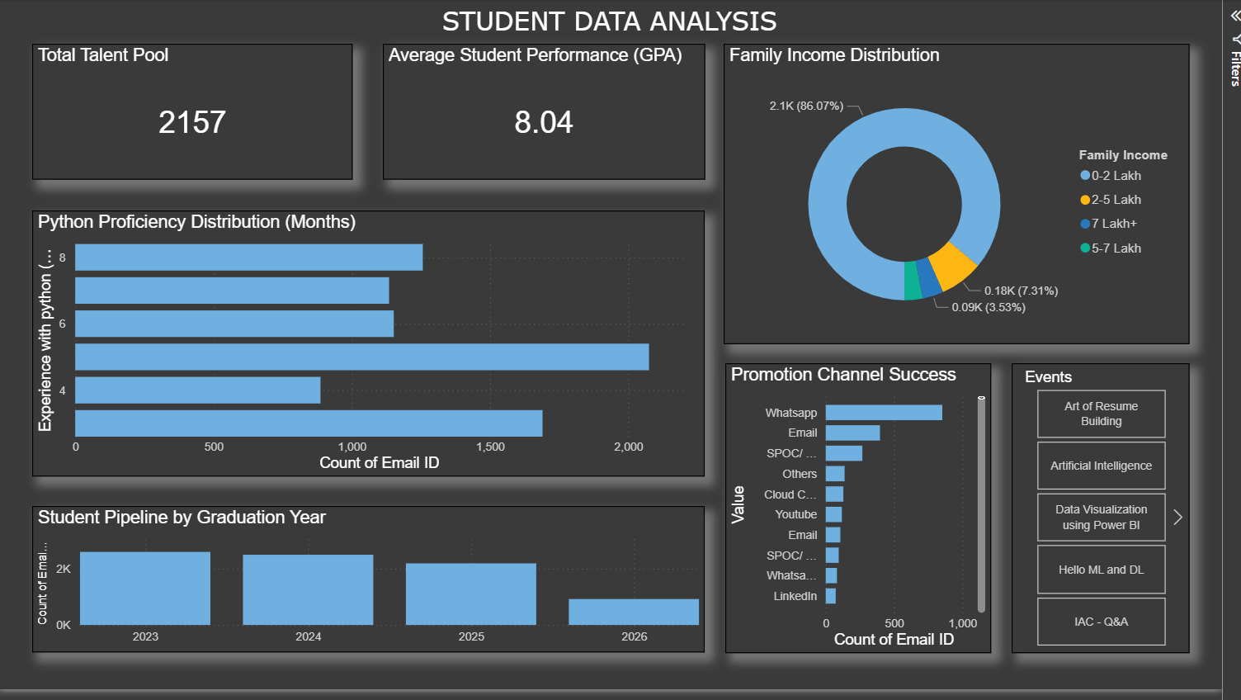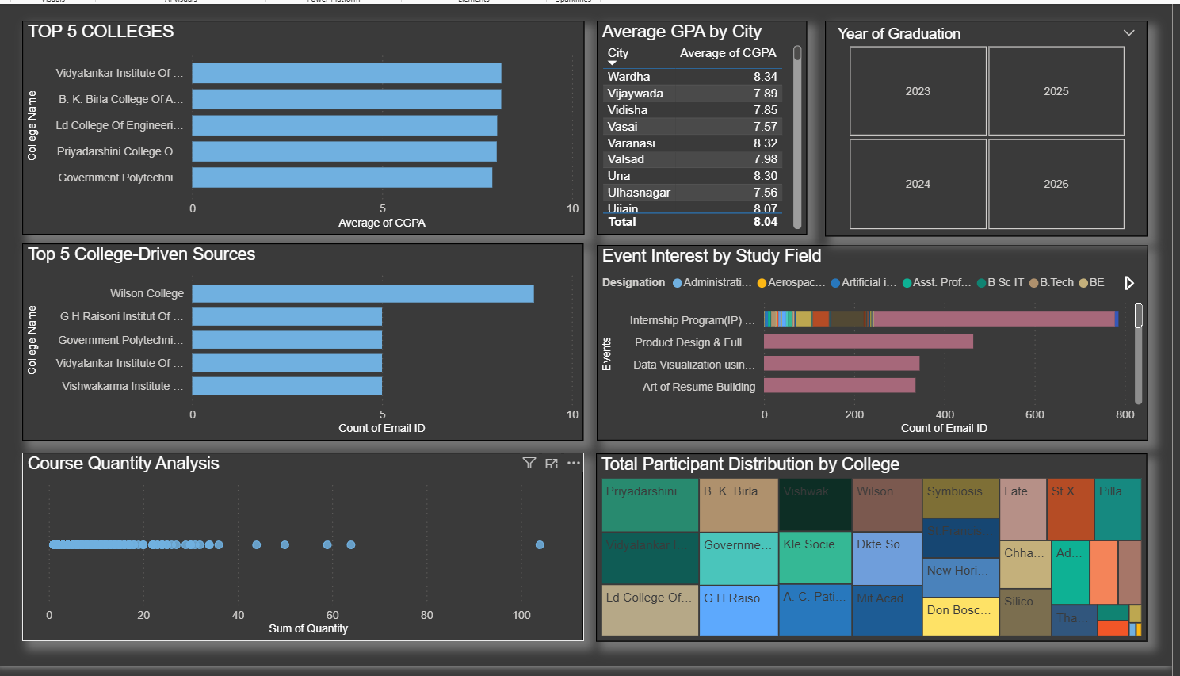 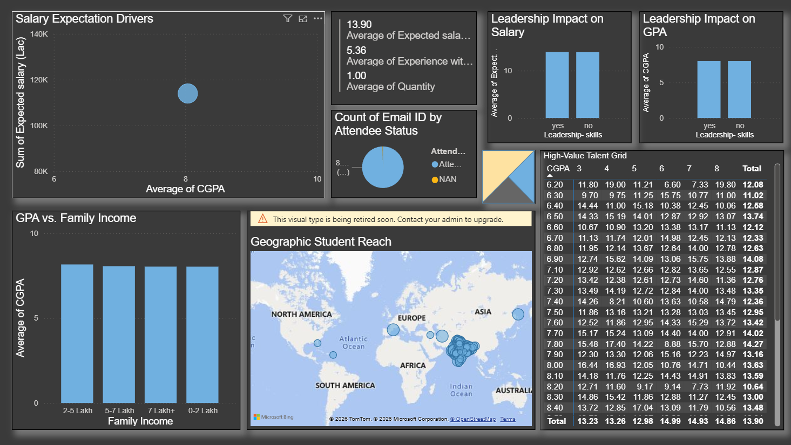
Page 1: Executive Overview
Focus: Key Performance Indicators (KPIs) and Technical Foundations.
- Q1 (Total Unique Students): Located at the Top-Left in the card titled "Total Talent Pool".
- Q2 (Average GPA): Located at the Top-Center in the card titled "Average Student Performance (GPA)".
- Q3 (Graduation Years): Located at the Bottom-Left in the bar chart titled "Student Pipeline by Graduation Year".
- Q4 (Python Experience): Located in the Large Middle-Left bar chart titled "Python Proficiency Distribution (Months)".
- Q5 (Family Income): Located at the Top-Right in the large Donut Chart titled "Family Income Distribution".
- Q14 (2024 Graduates): Located in the New Card added to the top row (per our final instruction).
- Q15 (Promotion Channels): Located at the Bottom-Right (Center) in the bar chart titled "Promotion Channel Success".
- Q16 (Data Science Interest): Located in the New Card added next to the Q14 card.
- Slicer (Events): Located on the Far Right to filter the entire page.

- Page 2: Institutional & Regional Deep-Dive
Focus: Comparisons between colleges, cities, and fields of study.
- Q6 (Top 5 Colleges): Located at the Top-Left in the bar chart titled "TOP 5 COLLEGES".
- Q7 (Quantity Outliers): Located at the Bottom-Left in the scatter plot titled "Course Quantity Analysis".
- Q8 (GPA by City): Located in the Top-Center in the scrolling Table titled "Average GPA by City".
- Q12 (Events vs. Field): Located in the Middle-Right in the multi-colored Stacked Bar Chart titled "Event Interest by Study Field".
- Q18 (College-Driven Leads): Located in the Middle-Left in the bar chart titled "Top 5 College-Driven Sources".
- Bonus Visual: Located at the Bottom-Right in the colorful Treemap titled "Total Participant Distribution by College".
- Slicer (Grad Year): Located at the Top-Right as a button-style slicer.

- Page 3: Strategic Career & Engagement Insights
Focus: Socioeconomic correlations and geographic mapping.
- Q9 (Income vs. GPA): Located at the Bottom-Left in the column chart titled "GPA vs. Family Income".
- Q10 (Geographic Reach): Located in the Large Center visual titled "Geographic Student Reach" (the Map).
- Q11 (Salary Drivers): Located at the Top-Left in the scatter plot titled "Salary Expectation Drivers".
- Q13 (Leadership Impact): Located at the Top-Right in two side-by-side column charts titled "Leadership Impact on Salary" and "Leadership Impact on GPA".
- Q17 (High-Value Talent): Located on the Far Right (taking up the vertical height) in the detailed Matrix titled "High-Value Talent Grid".
- Bonus Visuals: Your Attendee Status Pie Chart and Career Averages Card are located in the top-middle section.

